**MAIN PAGE**

SOURCE CODE:

<!DOCTYPE HTML>

<html>

<head>

<title>BookWorm</title>

</head>

<body style= "background-color: #E6E6FA;">

<h1 style=" padding-top:2%;padding-bottom:2%;color:white;background-color:#311432;margin:0;"><center>THE BOOK WORM STORE</center></h1>

<hr style="border-color: #3E424B;">

<div style="margin-left:20%;">

<p style="font: bold 15px monospace; font-size:20px">WELCOME :)</p>

<h2 style="font: italic bold 15px monospace; font-size:25px; background-color:white;margin-left:5%;margin-right:25%;padding:1%;"><center>"There is no friend as loyal as a book!"</center><h2>

</div>

<img style="display:block; margin-left:auto; margin-right:auto; width:20%;" src="b1.jpg"></img>

<div style="margin-left:5%;">

<p style="font: small-caps 15px Verdana; font-size:20px; text-align: center;">To continue your funtime and reading experience join our membership</p>

<p style="font: small-caps 15px Verdana; font-size:20px; text-align: center;">For more details click on the below link.</p>

<a style="font-family: Verdana"target= "_self" href=""><center>click here!</center></a>

<h3 style="font: small-caps 15px Verdana; font-size:20px; text-align: center;">Also checkout our new original merchandise from the link :-

<a target ="_blank" href="https://www.cafepress.ca/+bookworm+gifts" ><b>[NEW MERCHANDISE]</b></a></h3>

<br>

<h1 style="padding-left:5%; font-family: Arial;"><i><u>Latest Picks</u></i></h1>

<img style="padding:2%;" src="b2.jpg" width="200px" height="280px"></img>

<img style="padding:2%;" src="b3.jpg" width="200px" height="280px"></img>

<img style="padding:2%;" src="b4.jpg" width="200px" height="280px"></img>

<img style="padding:2%;" src="b5.jpg" width="200px" height="280px"></img>

<h3>FREE PREVIEWS AVAILABLE! </h3>

<a target="_blank" href="https://www.bing.com/ck/a?!&&p=dcc5affee1e56199JmltdHM9MTY5MTc5ODQwMCZpZ3VpZD0zZTU0MTExNC05Nzg0LTZhODYtM2I1OS0wMWUxOTYxZjZiZjAmaW5zaWQ9NTE5NA&ptn=3&hsh=3&fclid=3e541114-9784-6a86-3b59-01e1961f6bf0&psq=power+of+subconscious+mind+google+preview&u=a1aHR0cHM6Ly9kcml2ZS5nb29nbGUuY29tL2ZpbGUvZC8xQm1pUXd0Z1NWZzdsZHlxekdsQTBVSF9NelJQQndSblQvdmlldw&ntb=1">

<img style="padding:1%;" src="b6.jpg" height="300px" width ="200px"></img></a>

<a target="_blank" href="https://books.google.co.in/books?id=kRqeDwAAQBAJ&pg=PA1&source=gbs_selected_pages&cad=1#v=onepage&q&f=false">

<img style="padding:1%;" src="b7.jpg" height="300px" width ="200px"></img></a>

<a target="_blank" href="https://www.google.co.in/books/edition/Atomic_Habits/fFCjDQAAQBAJ?hl=en&gbpv=1&dq=atomic+habits&printsec=frontcover">

<img style="padding:1%;" src="b8.png" height="300px" width ="200px"></img></a>

<br><br>

</div>

<div style=" margin-left:10%; margin-right:11%;padding:1%;background-color:white;">

<ul style="font: small-caps 15px Verdana; font-size:20px;margin-left:10%">

<p><u>Book Genres</u></p>

<li>Mystery Novels</li>

<li>Action & Adventure Novels</li>

<li>Science Fiction Novels</li>

<li>Horror Novels</li>

<li>Romance Novels</li>

<li>Fantasy Novels</li>

</ul>

<br><br>

<ol style="font: small-caps 15px Verdana; font-size:20px;margin-left:10%">

<p><u>High rated Novels of 2k23:</u></p>

<li>The Silent Patient</li>

<li>Palace of Illusions</li>

<li>The Guest House</li>

</ol>

</div>

<dl style="margin-left:20%; background-color:white;margin-right:20%;padding-left:2%;margin-top:5%;margin-bottom:5%;padding-bottom:6%;">

<br><br>

<p style="font: italic 15px monospace; font-size:30px;">Upcoming books in the store...</p>

<dt style="font-size:20px;">NAMAHA <i> by Abhishek Singh</i></dt>

<img style="padding:1%;position:absolute; vertical-align:top;" src="nam.jpg" height="150px" width="100px"></img>

<dd style="margin-right:10%;margin-left:15%;margin-top:3%;font-size:22px;">A collection of short stories inspired by ancient wisdom literature of India.

Abhishek Singh's work is acclaimed around the world for its unique style and storytelling with

compelling illustrations and enthralling text, Singh takes you into the fantastical worlds of ancient

Indian mythology, deciphering its many symbolic humanistic and ecological layers.</dd>

<br><br><dt style=" margin-top:3%;font-size:20px;">CIRCE <i> by Madeline Miller</i></dt>

<img style="padding:1%;position:absolute; vertical-align:top;" src="cir.jpg" height="150px" width="100px"></img>

<dd style="margin-right:10%;margin-left:15%;margin-top:3%;font-size:22px;">

In the house of Helios, god of the sun and mightiest of the Titans,

a daughter is born. But Circe is a strange child--neither powerful like

her father nor viciously alluring like her mother.

Turning to the world of mortals for companionship, she discovers that she does possess power:

the power of witchcraft, which can transform rivals into monsters and menace the gods themselves.

</dd>

<br><br>

<dt style="margin-top:3%;font-size:20px;">IKIGAI <i> by Abhishek Singh</i></dt>

<img style="padding:1%;position:absolute; vertical-align:top;" src="iki.jpg" height="150px" width="100px"></img>

<dd style="margin-right:10%;margin-left:15%;margin-top:3%;font-size:22px;">The concept of ikigai is said to have evolved from the basic health and wellness principles

of traditional Japanese medicine. This medical tradition holds that physical wellbeing is affected by one’s

mental–emotional health and sense of purpose in life.</dd>

<br><br>

<dt style="margin-top:3%;font-size:20px;">SHIVA TRILOGY<i> by Amish Tripathi</i></dt>

<img style="padding:1%;position:absolute; vertical-align:top;" src="shiva.jpg" height="150px" width="100px"></img>

<dd style="margin-right:10%;margin-left:15%;margin-top:3%;font-size:22px;">The story follows Shiva, a tribal chief from Tibet, who discovers his destiny as the Mahadev,

the God of Gods, in ancient India. This novel signifies the journey of this great energy.</dd>

</dl>

<br><br><br><br>

<hr style="height:2px;color:gray;background-color:gray;width:70%;">

<table border ="1" style=" background-color:white;width:70%;margin-left:15%; margin-top:3%;font: small-caps 15px Verdana; font-size:20px;">

<caption>Trending Authors</caption>

<tr>

<th>Rank</th>

<th>Author</th>

<th>Best Selling</th>

<th>Recent Launch</th>

</tr>

<tr>

<td>01</td>

<td>Colleen Hoover</td>

<td colspan="2" style="text-align:center">It Ends With Us</td>

</tr>

<tr>

<td>02</td>

<td>Amish Tripathi</td>

<td>Ram</td>

<td>Sita</td>

</tr>

<tr>

<td>03</td>

<td rowspan="2">Chitra Benerjee Divakaruni</td>

<td>The Palace of Illusions</td>

<td>The Forest Enchantments</td>

</tr>

<tr>

<td>04</td>

<td>Karna's Wife</td>

<td>Sita's Sister</td>

</tr>

</table>

<br><br>

<hr style="height:2px;color:gray;background-color:gray;width:70%;">

<div style="padding:2%;">

<a target="_blank" href="file:///C:/Users/Tanvi/OneDrive/Documents/SYCOMP/MADF%20lab/assi2.html">

<i style="font: italic 15px monospace;margin-left:15%;margin-right:35%;color:white;font-size:20px; color:#311432;background-color:white;">For User Sign-up</i>

</a>

<a target="_blank" href="file:///C:/Users/Tanvi/OneDrive/Documents/SYCOMP/MADF%20lab/assi2_2.html">

<i style="font: italic 15px monospace;margin-left:;color:white;font-size:20px; color:#311432;background-color:white;">Book Entry (Staff Only)</i>

</a>

</div>

<div style="padding:3%;background-color:#311432;">

</div>

</body>

</html>

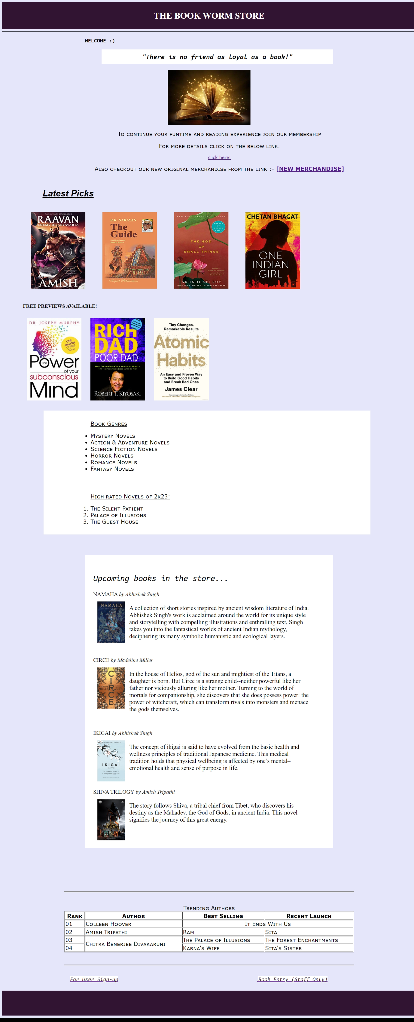

**SIGN UP PAGE**

SOURCE CODE:

<!DOCTYPE HTML>

<html>

<head>

<title>Sign Up Page</title>

</head>

<body style= "">

<h2 style=" padding-top:2%;padding-bottom:2%;color:white;background-color:#784B84;margin:0;"><center>(USER DETAILS SUBMISSION FORM)</center></h2>

<hr style="height:2px;color:gray;background-color:gray">

<br><br>

<div style="border:2px solid gray;width:40%;margin-top:-2%;margin-left:25%;padding:2%;">

<img style="display:block; margin-left:auto; margin-right:auto; width:250px;height:15%;" src="user.png"><h2 style="text-align:center;color:grey;">USER SIGN UP<h2></img><br><br>

<form method="Get" action="" autocomplete="on" style="margin-left:20%;font: small-caps 15px Verdana; font-size:20px;">

<label>Enter Your Name: </label><br>

<input type="text" maxlength="20" id="fn" placeholder="First Name" autofocus >

<input type="text" maxlength="20" id="ln" placeholder="Last Name"><br><br>

<label>Enter Email-id: </label><br>

<input type="email" id="emid" placeholder="email" ><br><br>

<label>Sign Up as: </label>

<input type="text" readonly value="User"><br><br>

<label>Subscription Applied : </label>

<input type="Text" disabled value="Monthly Plan"><br>

<br>

<label>Enter your favourite genre: </label><br>

<input type="checkbox" id="">Thriller<br>

<input type="checkbox" id="">Non Fiction<br>

<input type="checkbox" id="">Sci-Fi<br>

<input type="checkbox" id="">Romance<br>

<input type="checkbox" id="">Mythology<br>

<input type="checkbox" checked id="">All of the above<br>

<input type="checkbox" id="">Other<br><br>

<br>

<label>Enter Gender: </label><br>

<input type="radio" id="" name="rb">Male<br>

<input type="radio" id="" name="rb">Female<br>

<input type="radio" id="" name="rb">Other<br><br>

<br>

<label>Choose Country: </label><br>

<select size="">

<option value="" >Germany</option>

<option value="" >USA</option>

<option value="" >Japan</option>

<option value="" >Canada</option>

<option value="" >China</option>

<option value="" >Russia</option>

<option value="" >South Korea</option>

<option value="" selected >India</option>

<option value="" >France</option>

<option value="" >Australia</option>

<option value="" >United Kingdom</option>

<option value="" >Brazil</option>

</select><br><br>

<label>Enter your Age: </label>

<input type="number" min="14" max="100"><br><br>

<label>Enter DOB: </label>

<input type="date"><br><br>

<label>Enter your identity proof: </label>

<input type="file"><br><br>

<label>Select Cover page color: </label>

<input type="color"><br>

<br><br>

<input type="reset" value=" "><b> Reset</b>

<input type="submit" value=" " style="margin-left:50%;"><b> Submit</b><br>

</form>

</div>

<div style="padding-bottom:8%;">

</div>

<hr style="height:2px;color:gray;background-color:gray">

<div style="padding:3%;background-color:#784B84;">

</div>

</body>

</html>

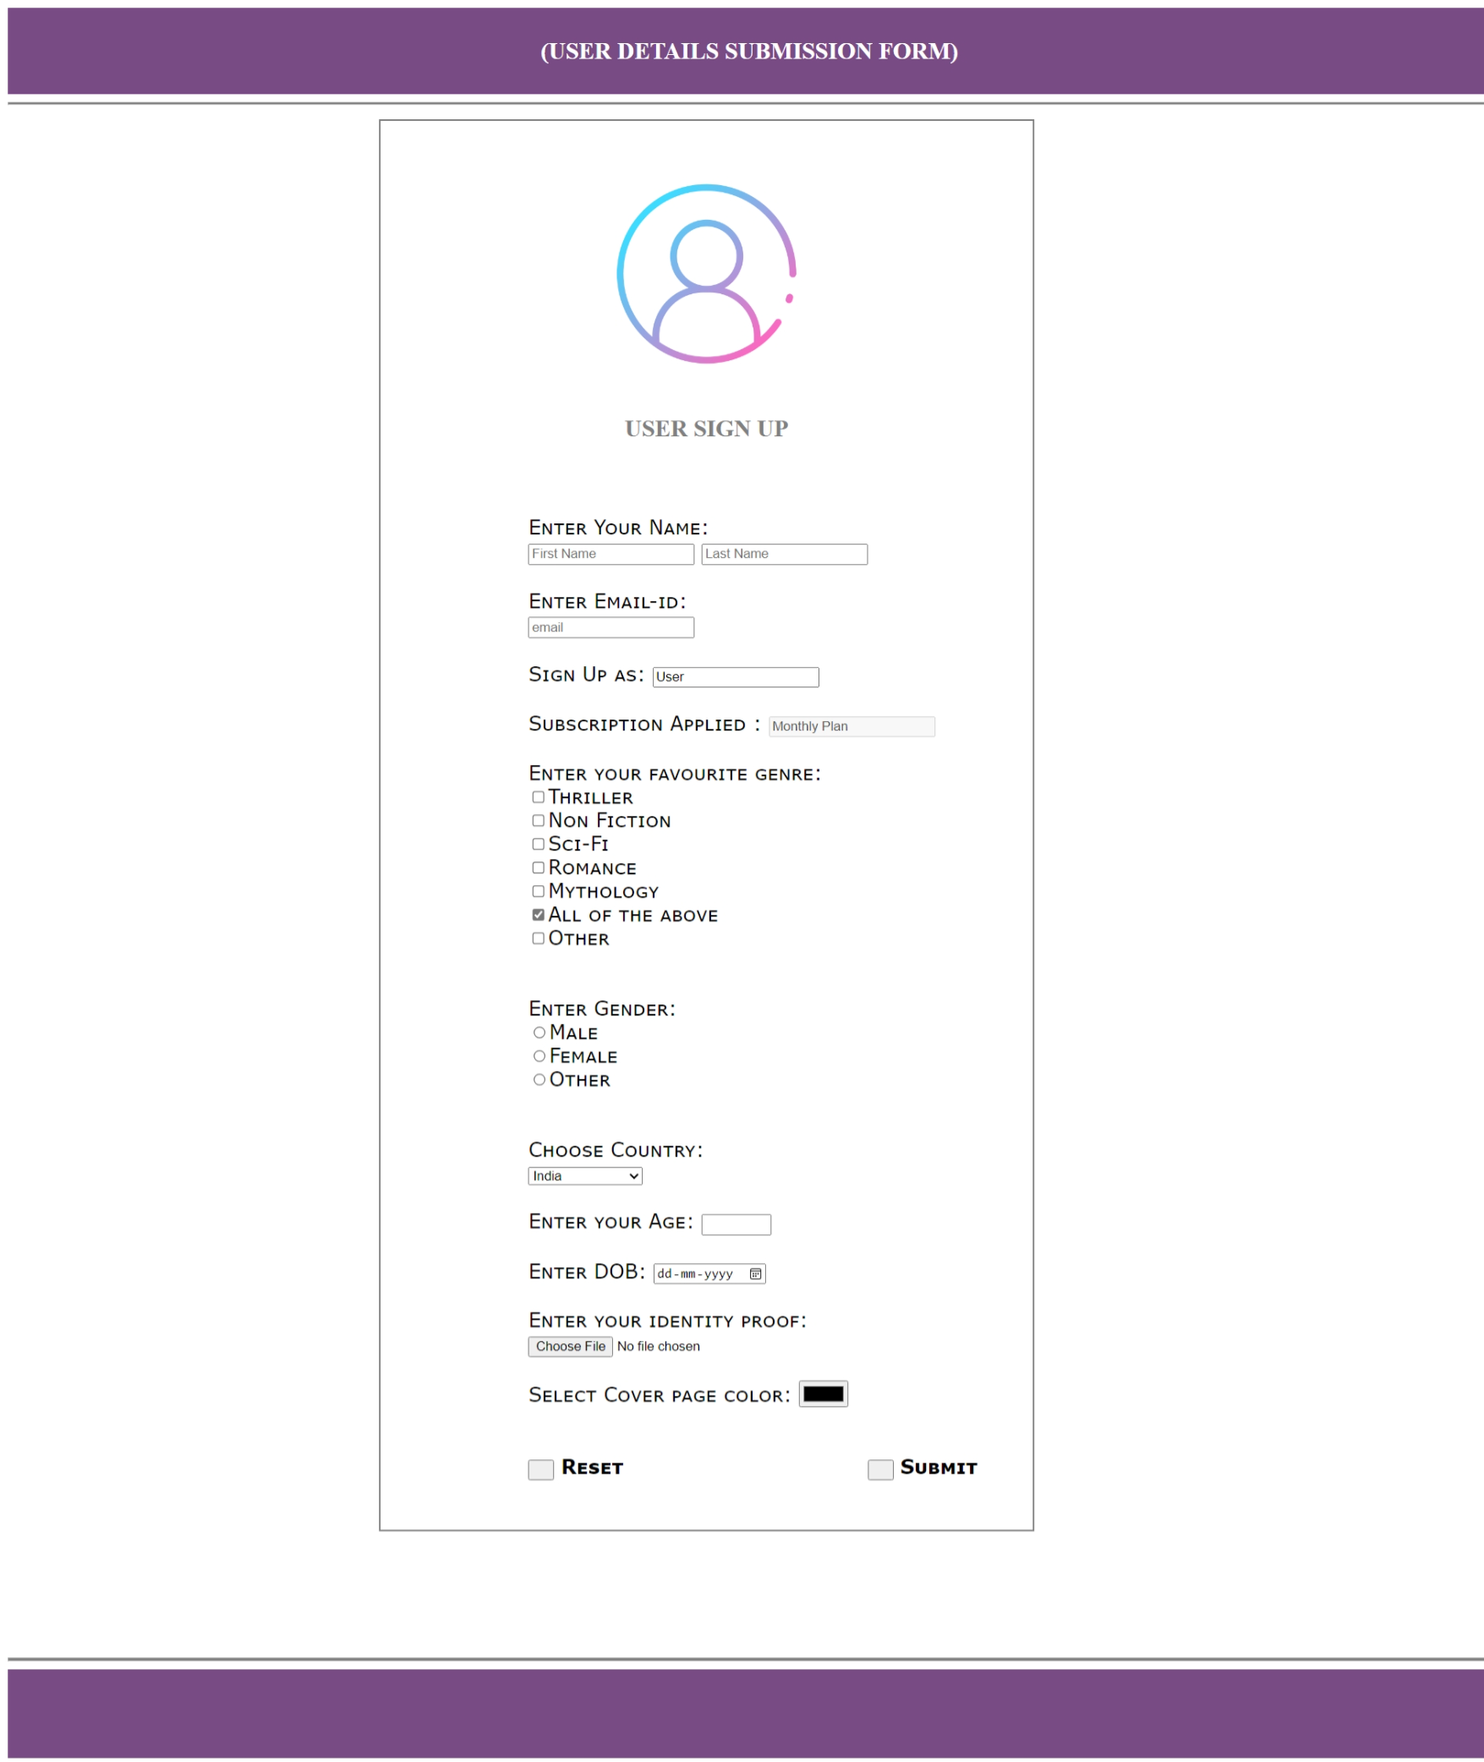

**BOOK ENTRY PAGE**

SOURCE CODE:

<!DOCTYPE HTML>

<html>

<head>

<title>BOOK ENTRY</title>

</head>

<body style= "">

<h2 style=" padding-top:2%;padding-bottom:2%;color:white;background-color:#784B84;margin:0;"><center>NEW BOOK ENTRIES</center></h2>

<hr style="height:2px;color:gray;background-color:gray">

<img align="right" style="height:100%;width:37%;margin-top:7px;" src="back.jpg"></img>

<br><br>

<div style="border:2px solid;width:40%;margin-top:-2%;margin-left:25%;padding:2.6%;">

<form method="Get" action="" autocomplete="on" style="margin-left:20%;font: small-caps 15px Verdana; font-size:20px;">

<label>Enter Author Name: </label><br>

<input type="text" maxlength="20" id="fn" placeholder="First Name" autofocus >

<input type="text" maxlength="20" id="ln" placeholder="Last Name"><br><br>

<label>Logged In as: </label>

<input type="text" readonly value="Admin/Staff"><br><br>

<label>Purchase Mode : </label>

<input type="Text" disabled value="OFFLINE"><br>

<br>

<label>Enter book genre: </label><br>

<input type="checkbox" id="">Thriller<br>

<input type="checkbox" checked id="">Fiction<br>

<input type="checkbox" id="">Non Fiction<br>

<input type="checkbox" id="">Sci-Fi<br>

<input type="checkbox" id="">Romance<br>

<input type="checkbox" id="">Mythology<br>

<input type="checkbox" id="">Other<br><br>

<br>

<label>Enter nationality: </label><br>

<input type="radio" id="" name="rb">Domestic<br>

<input type="radio" id="" name="rb">International<br>

<br>

<label>Select Publishing Country: </label><br>

<select size="">

<option value="" >Germany</option>

<option value="" >USA</option>

<option value="" >Japan</option>

<option value="" >Canada</option>

<option value="" >China</option>

<option value="" >Russia</option>

<option value="" >South Korea</option>

<option value="" selected >India</option>

<option value="" >France</option>

<option value="" >Australia</option>

<option value="" >United Kingdom</option>

<option value="" >Brazil</option>

</select><br><br>

<label>Enter Copies: </label>

<input type="number" min="14" max="100"><br><br>

<label>Date of Publishing: </label>

<input type="date"><br><br>

<label>Attach Billing proof: </label>

<input type="file"><br><br>

<label>Select Color Code: </label>

<input type="color"><br><br>

<hr style="height:2px;color:gray;background-color:gray">

<br><br>

<input type="reset" value=" "><b> Reset</b>

<input type="submit" value=" " style="margin-left:30%;"><b> Submit</b><br>

</form>

</div>

<div style="padding-bottom:8%;">

</div>

<hr style="height:2px;color:gray;background-color:gray">

<div style="padding:3%;background-color:#784B84;">

</div>

</body>

</html>

